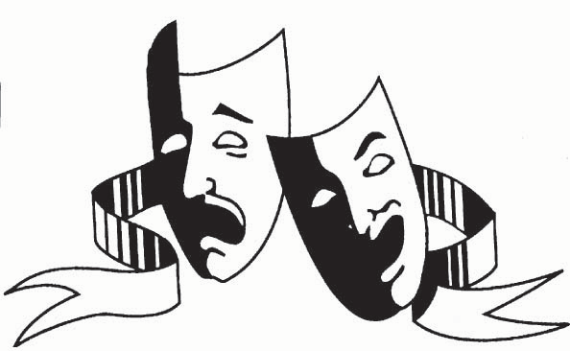Review Exam 1 Chapter 8

**DRAMA** FO YO MOMMA… No, but seriously all drama

To help with this portion, try and recall Michael Shraeter’s lecture (which btw, I thought was great and honestly he does an amazing job at teaching. Not as funny or entertainingly awkward Winston can be, but let’s be honest, if I was a theatre major I’d want him teaching me)

FIRSTLY, **Drama** is a collaborative art that represents events and situations, either realistic and/or symbolic, that we witness happening through the actions of actors in a play on a stage in front of a live audience.

LET US REMEMBER THE **6 MAIN ELEMENTS OF DRAMA**

* Plot – arrangement of incidents
* Character – presentation of a person or persons
* 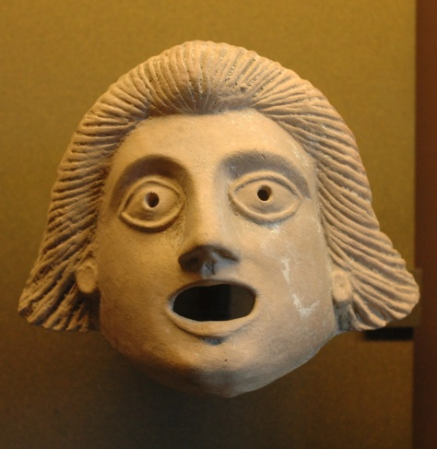Thought – the ideas that underlie the plot, theme
* Diction/ Dialog – language of the drama
* Spectacle – costumes, set design
* Song

**3 Major Greek Playwrights**

* Aeschylus
* Sophocles
* Euripides

Oh and also worth mentioning, Aristophanes

Origins

**Myth:** sacred narrative usually explaining how the world or humankind came to be in its present form.

Greeks and the birth of Tragedy (pity/fear) (*Goat Song*)  
Aristotle sought for this

**Dithyramb**: hymn sung at the altar of god Dionysus

Theatre of Dionysus held 17000+ people

\***The Three Unities**

- Unity of Time: action in a play take no more than 24 hour time period   
 - Unity of Action: one main action; no or few sub plots  
 - Unity of Place: single physical space… nor should the stage represent more than one place

**Roman Theatre**

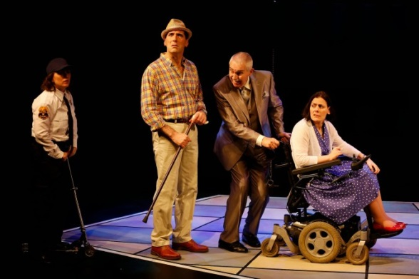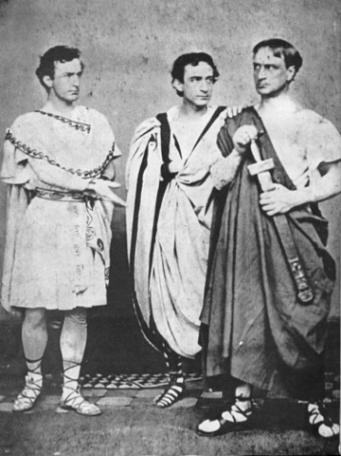Improv Farse – form of comedy includes physical/sexual comedy (low-brow)  
Masques  
Mystery

**The Elizabethans**

(*Shakespeare*)Audience enjoyed naturalness/realism

**19th Century**

(*Booth Brothers*)   
Stalk movements

**1880s**

(*Konstantin Stanislavsky*) – THE METHOD*  
This guy had MONEY $$$, and joined the theatre, which is unheard of!!! Russian theatre to be exact  
Started the Moscow Art Theatre  
He strived for realism, psychoanalysis… wanted the actors to use emotional recall. (remembering moments in their lives that made them relive specific emotional moments) THE METHOD*

**20th Century American Acting Teachers**

* Lee Strasberg
* Sanford Meissner
* Stell Adler
* Uta Hagen